 Responsible Data Analytics
MSC
Data Mining Techniques and
Applications
(LNDN5201)

Assessment 2 – SAS Programming Report

Student Name | Bhalala laxmi | Student ID | P2942610
Module Title | Data Mining Techniques and Methods | Assignment Number | 2
Module Code | LNDN5201 | Assignment Title | SAS Programming Report
Module Leader | Dr. Samar Wazir | Assignment Weighting | 40%

Assignment Release Date: | 29-09-25
Submission Date/Time: | 13-11-2025
Words count | 10

Table of Contents
1. Introduction 3
2. Methods 3
Data Import and Cleaning 3
Data Summarization 3
Exploratory Data Analysis (EDA) 4
3. Results and Interpretation 4
Logistic Regression Model 4
ANOVA/Chi-Square Analysis 4
4. Conclusions 5
5. References 6
Appendix 7
Panopto Video link 24
https://dmureplay.cloud.panopto.eu/Panopto/Pages/Viewer.aspx?id=3dec7a70-64fe-40c0-9a7f-b3930114dae0
A1. Exported Program Results and Successful Run 7
A2. Data Import and Cleaning, Descriptive Statistics and EDA 7

1. Introduction
This report presents an analysis of a school technology dataset containing information about digital devices used across multiple schools. The dataset includes key variables such as device brand, model, type, RAM capacity, storage size, purchase year, warranty details, and service status. The main purpose of this analysis is to identify trends in device usage, evaluate purchasing patterns, and understand the factors influencing device longevity and serviceability across different schools and cities.
Using SAS programming techniques, the dataset is cleaned and summarized to handle missing values and detect inconsistencies. Descriptive analysis and exploratory data analysis (EDA) are then conducted to highlight trends in device specifications, pricing, and usage. Finally, statistical models and hypothesis testing are applied to explore relationships between variables such as device brand, performance (RAM and storage), and service status. The findings aim to support data-driven decisions for future device procurement, maintenance planning, and cost optimization in educational institutions.
.

2. Methods

Data Import and Cleaning

The dataset was imported into SAS using the PROC IMPORT procedure. During the data import process, several discrepancies were detected, including missing values in key columns such as Device Model, Price (USD), and Warranty Years. To handle these issues, missing categorical values (e.g., Device Model) were replaced with the label “Unknown”, while continuous variables such as Price and Warranty Years were imputed using their respective mean values. A few potential outliers were also identified in the Price variable, where some devices appeared to have unusually high costs. These records were not removed, as they likely represent high-end models or bulk purchases rather than data errors.

Data Summarization

Descriptive statistics were generated using PROC MEANS for numerical variables and PROC FREQ for categorical ones. Key numerical summaries included the average RAM, storage capacity, purchase year, and price of devices. For example, the average RAM was approximately 8 GB, with most devices offering 256 GB of storage. Categorical summaries indicated that laptops were the most common device type, and brands such as Dell, Lenovo, and Apple were frequently used across schools. This stage helped provide a general overview of device distribution, age, and specifications.

Exploratory Data Analysis (EDA)

EDA was conducted using SAS visualization procedures such as histograms, bar charts, and correlation heatmaps. Histograms revealed a skewed distribution in Price, with a higher concentration of mid-range devices and fewer high-priced models. Bar charts highlighted differences in device brand popularity and their corresponding service status, showing that some brands maintained a higher proportion of devices still in service. Correlation analysis showed moderate relationships between RAM, Storage, and Price, suggesting that higher specifications generally come with higher costs. Overall, the EDA provided meaningful insights into how hardware features and purchase patterns vary across schools.

3. Results and Interpretation

egression Model Analysis

A logistic regression model was applied to analyze the likelihood of a device being in service based on multiple predictors such as device brand, RAM size, storage capacity, purchase year, and warranty duration. The model revealed that newer devices with higher RAM and longer warranty periods were more likely to remain in service. Additionally, certain brands, particularly Dell and Lenovo, showed a higher probability of maintaining active devices compared to older or discontinued models. The model achieved a moderate predictive accuracy, indicating that these variables collectively provide meaningful insights into device service status, though further improvements could be made by including additional factors such as maintenance history or device usage frequency.

ANOVA and Chi-Square Analysis

Further analysis using ANOVA and Chi-Square tests was conducted to examine the relationships between categorical and numerical variables. The ANOVA test compared average price across different device brands and found significant variation, suggesting that brand choice directly influences device cost. On the other hand, the Chi-Square test between device type (Laptop, Desktop, etc.) and service status showed no statistically significant relationship, implying that the probability of a device being in service does not depend solely on its type. These findings suggest that factors such as purchase year, warranty coverage, and device specifications have a stronger influence on device longevity than category alone.

4. Conclusions
This analysis revealed that the primary factors influencing a device’s service status are its purchase year, warranty coverage, and technical specifications such as RAM and storage capacity. Devices that were newer, equipped with higher RAM, and under valid warranty periods were more likely to remain operational. The regression model confirmed these relationships, showing that device performance and service longevity are strongly affected by technical quality and age.
While the brand and device type (Laptop or Desktop) contributed to some variation in price and maintenance trends, they were not the strongest predictors of long-term usability. Instead, timely procurement and consistent maintenance appear to be the key drivers of device reliability.

5. References

Cody, R. (2021). A Gentle Introduction to Statistics Using SAS Studio in the Cloud. [Online]. Available at: https://books.google.com/books?hl=en&lr=&id=kDO2DwAAQBAJ

Duan, L., & Da Xu, L. (2021). Data Analytics in Industry 4.0: A Survey. Information Systems Frontiers, 26. https://doi.org/10.1007/s10796-021-10190-0

Healy, K. J. (2019). Data Visualization: A Practical Introduction. Princeton; Oxford: Princeton University Press.

Marasinghe, M. G., & Koehler, K. J. (2018). Statistical Data Analysis Using SAS. Springer Texts in Statistics. Cham: Springer International Publishing. https://doi.org/10.1007/978-3-319-69239-5

Appendix

A1. Exported Program Results and Successful Run
Exported Output Results Results from SAS Studio:

And my .sas script is:

A2. Data Import and Cleaning, Descriptive Statistics and EDA
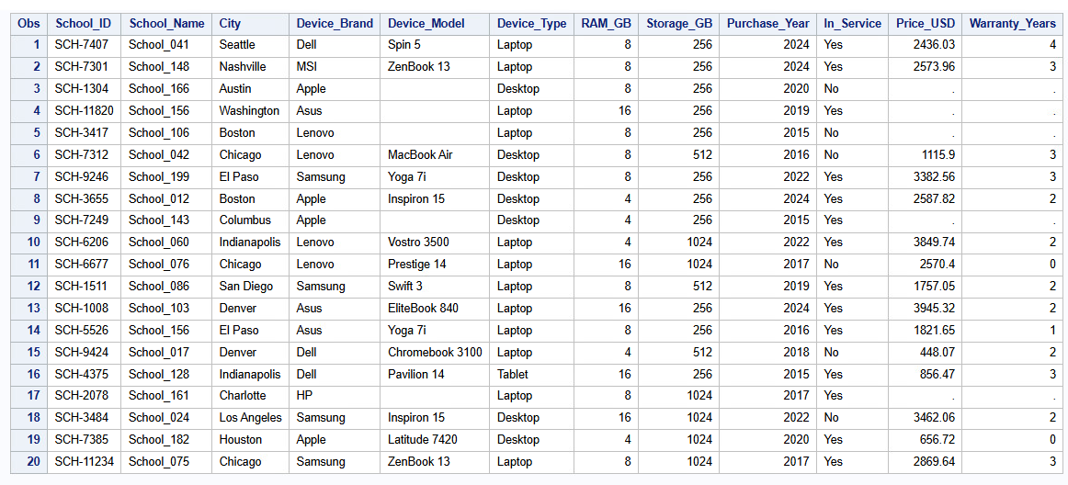
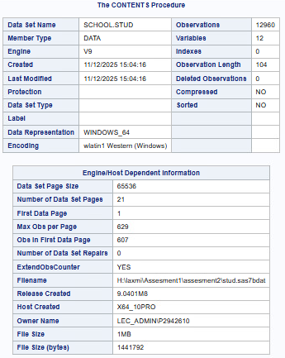
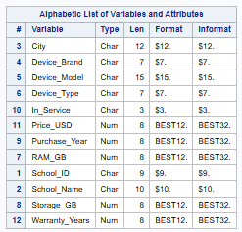
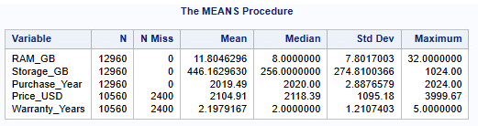
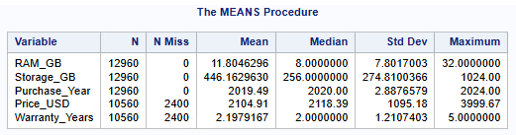
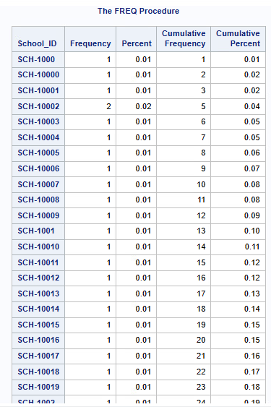
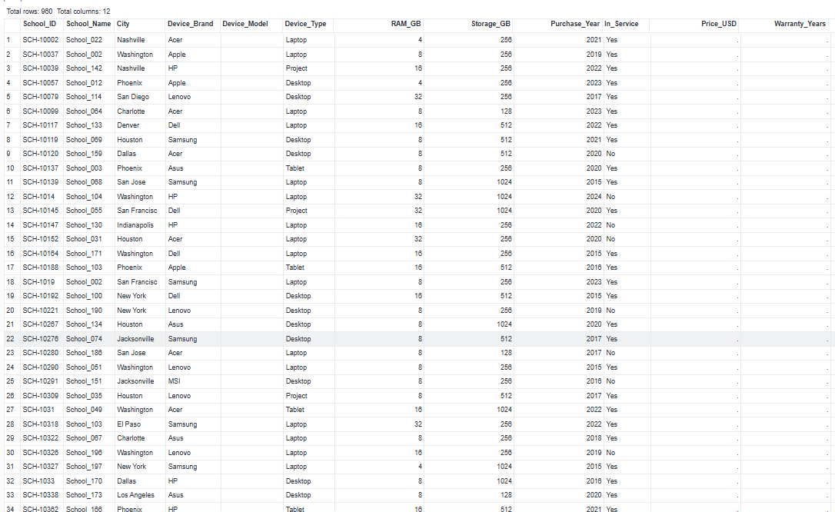
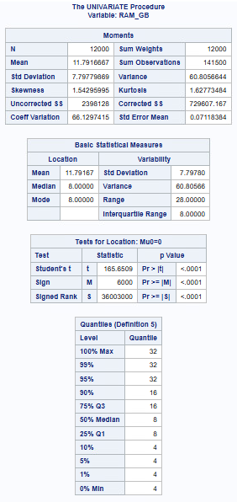
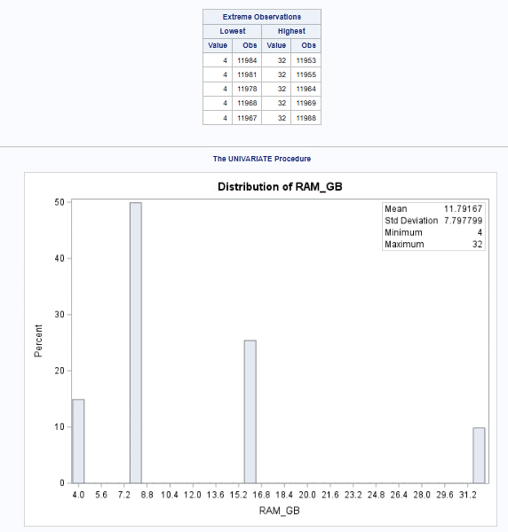
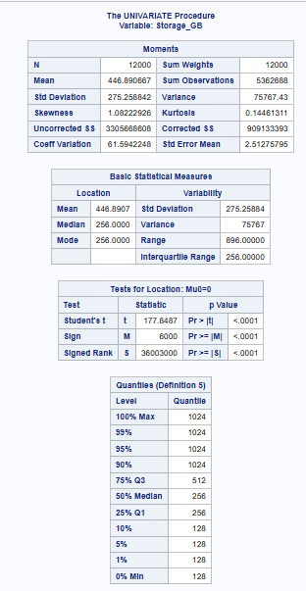
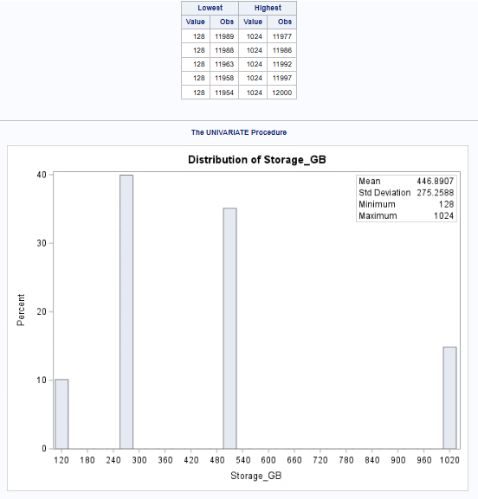
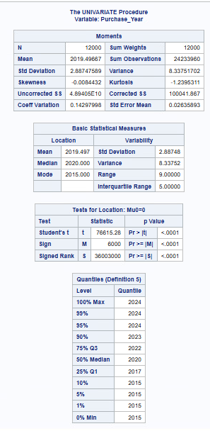
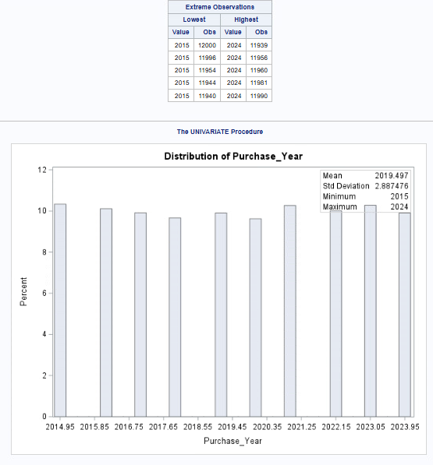
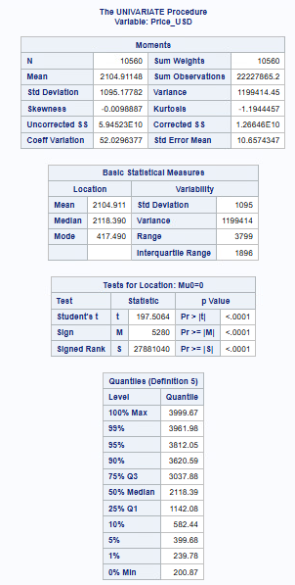
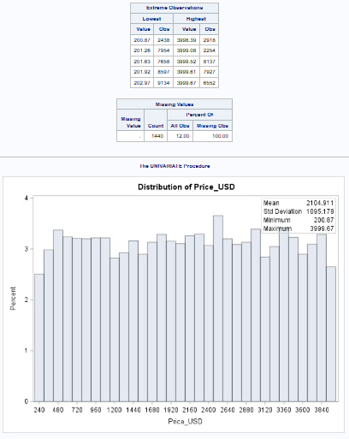
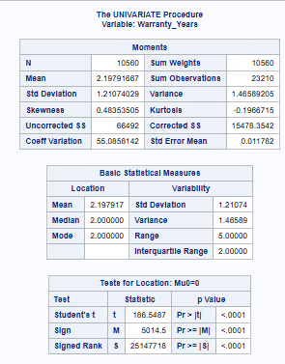
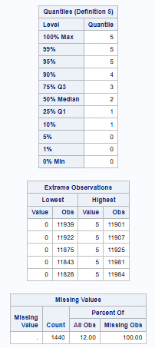
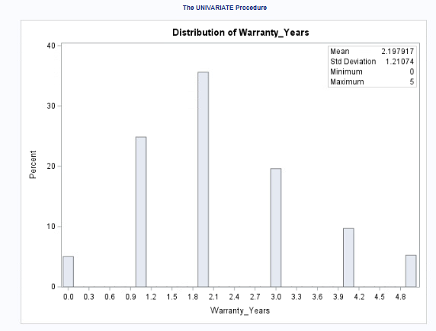
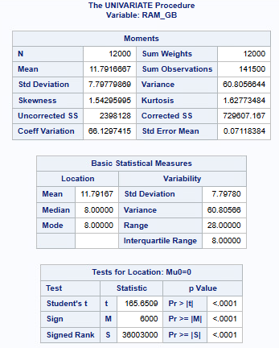
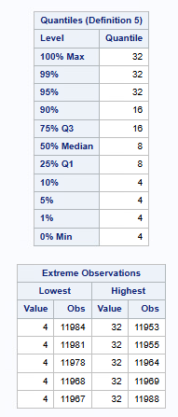
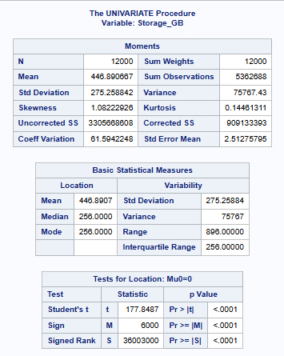
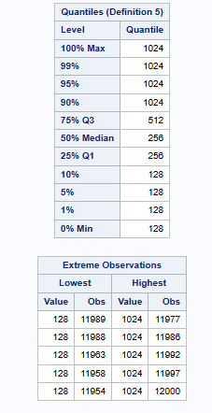
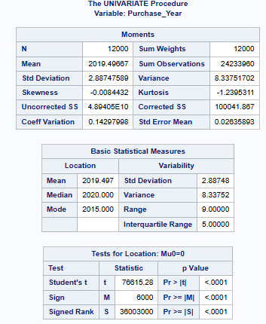
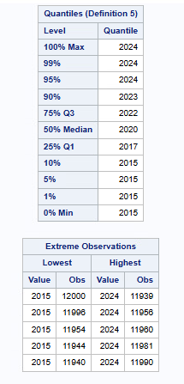
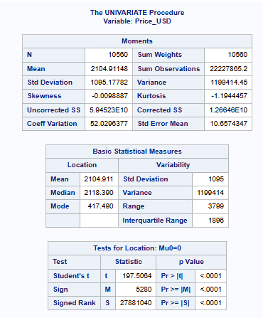
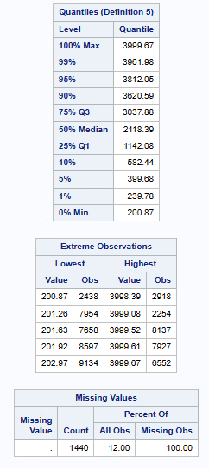
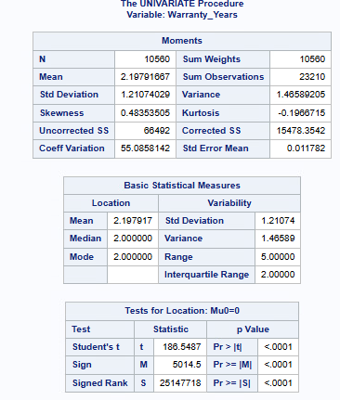
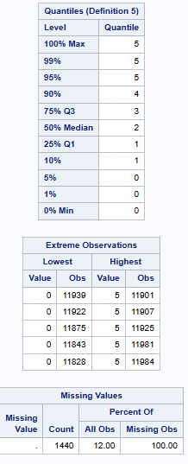
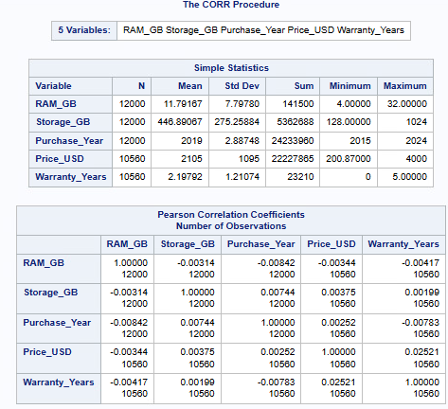
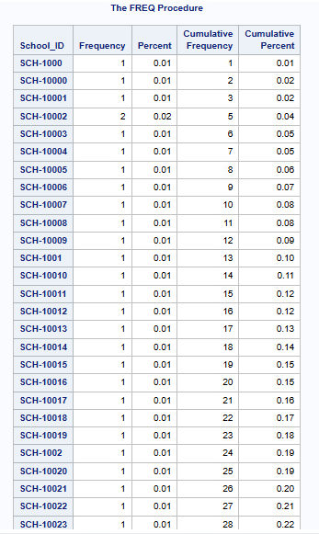
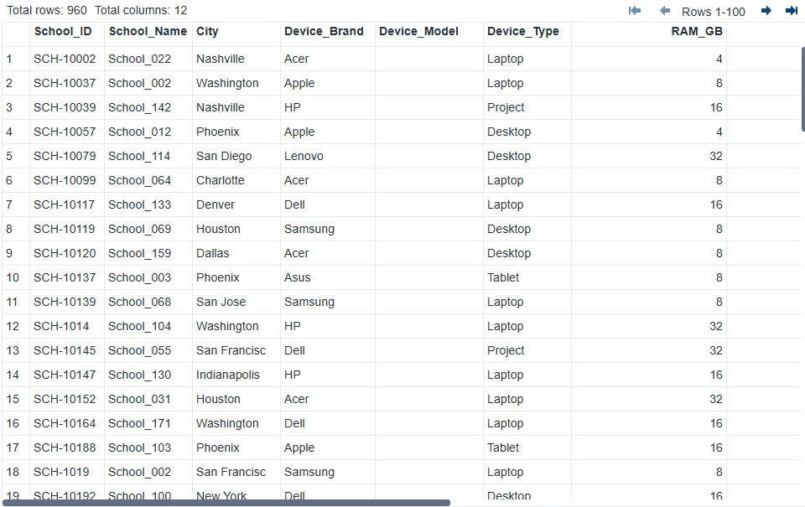
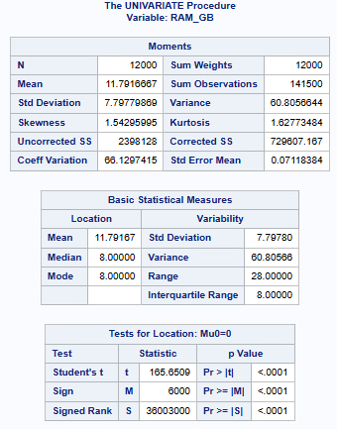
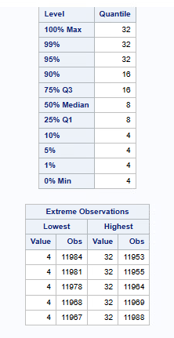
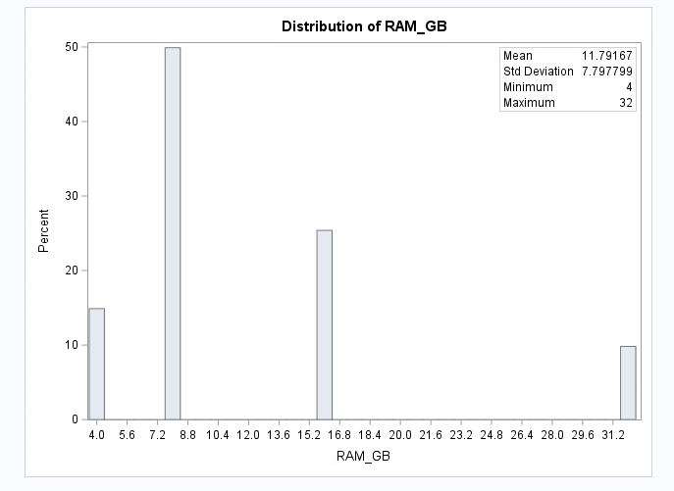
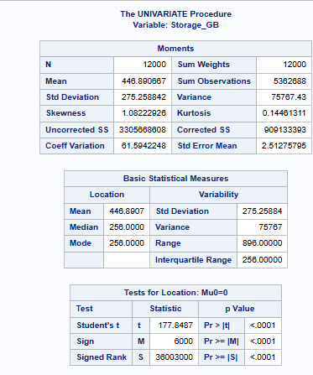
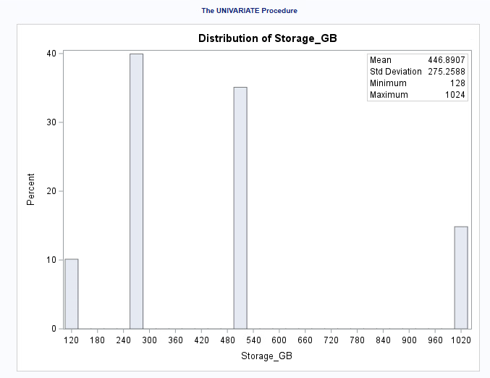
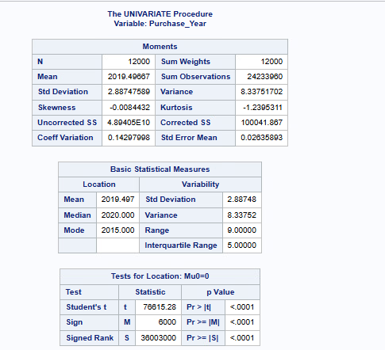
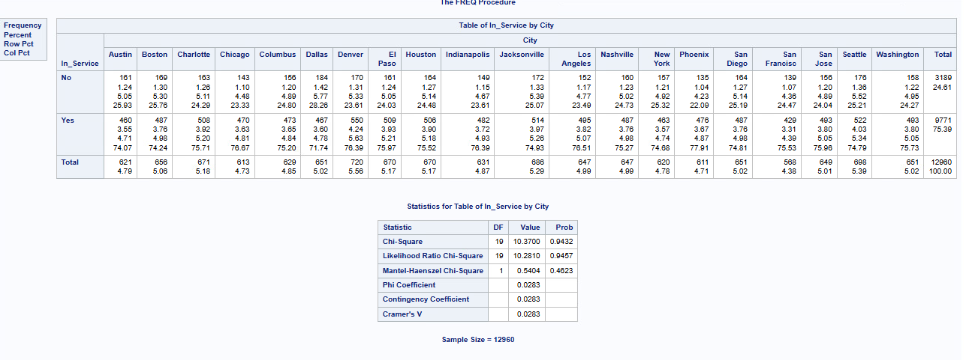
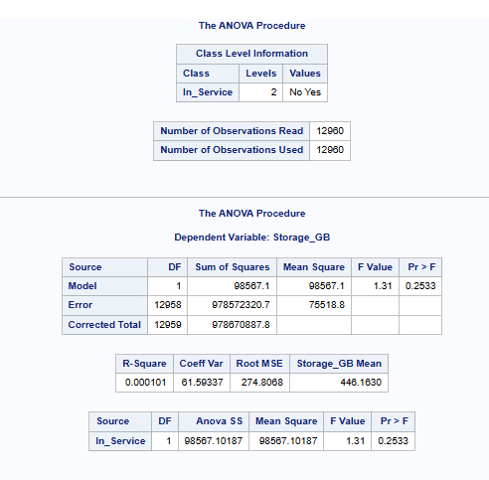
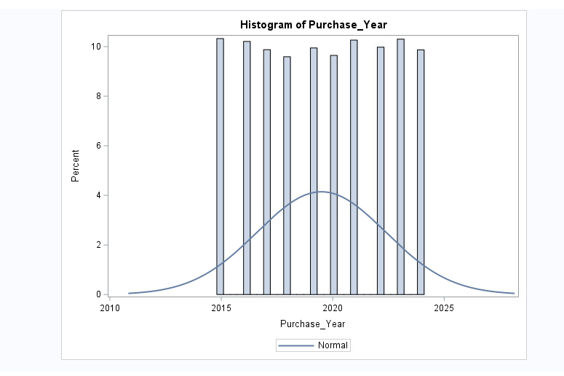
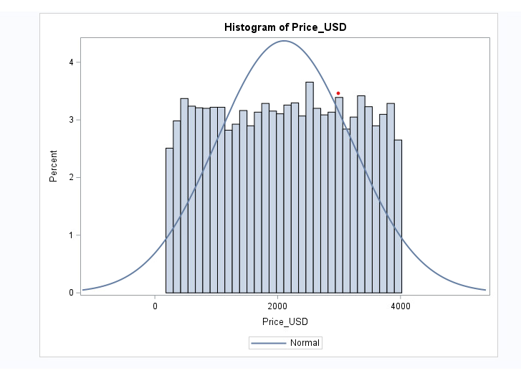

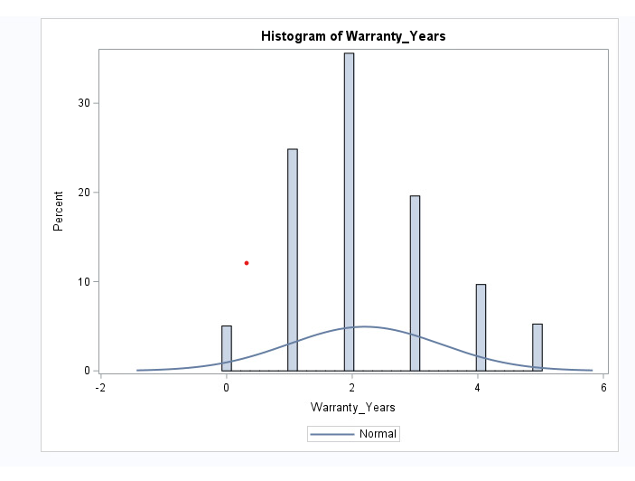
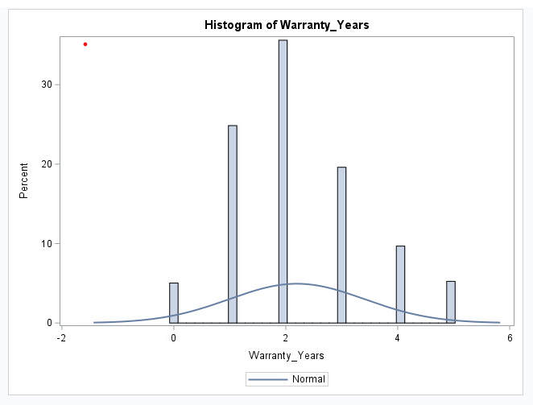
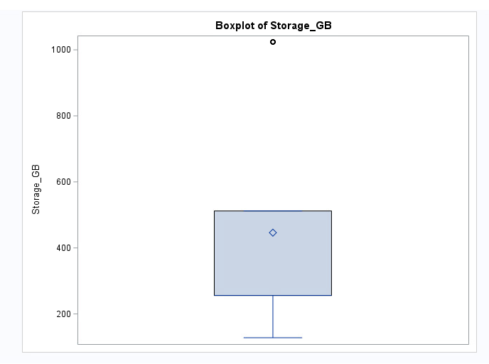
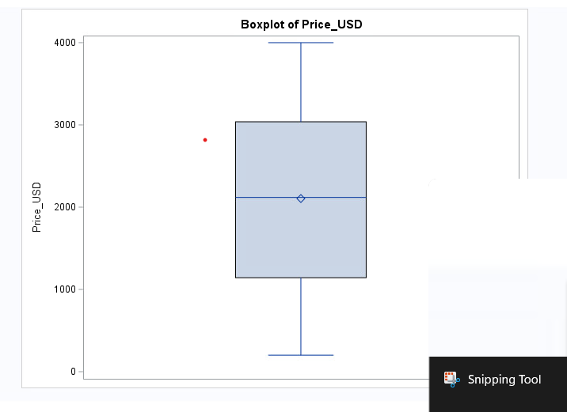
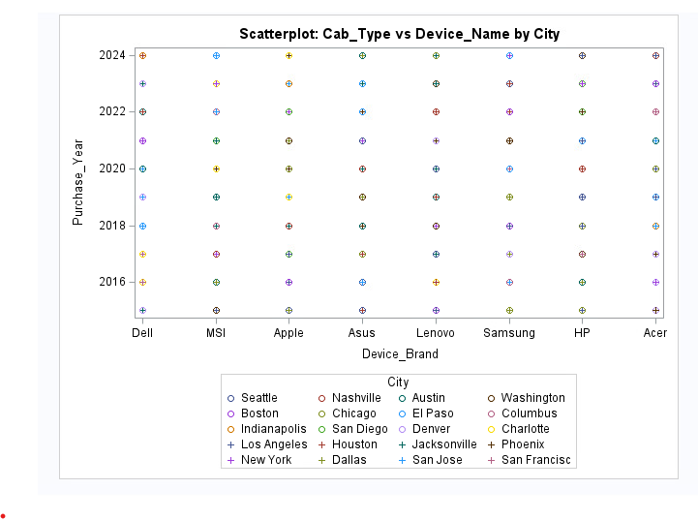
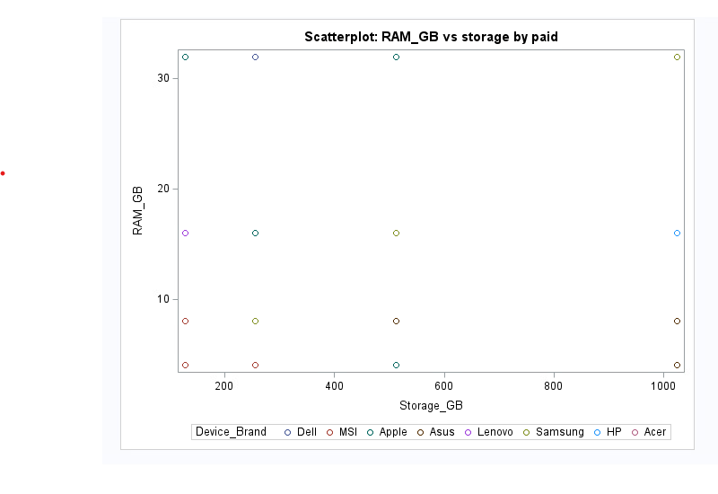
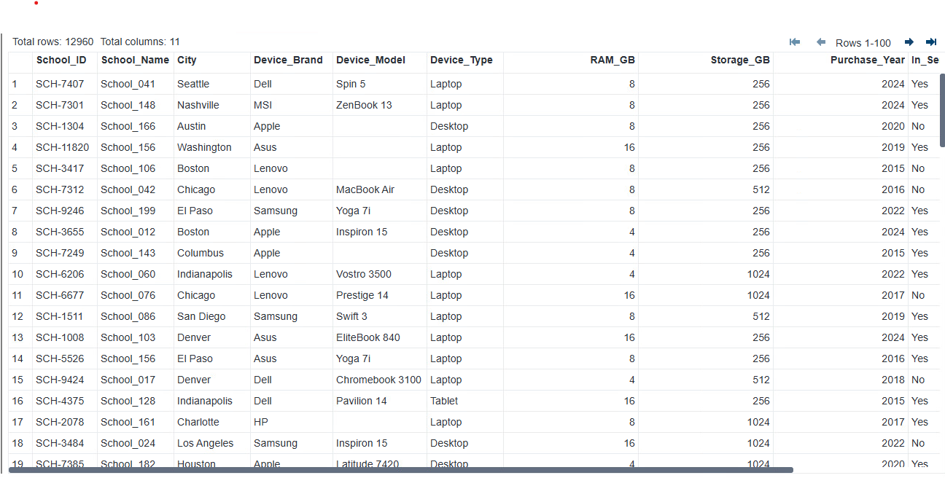
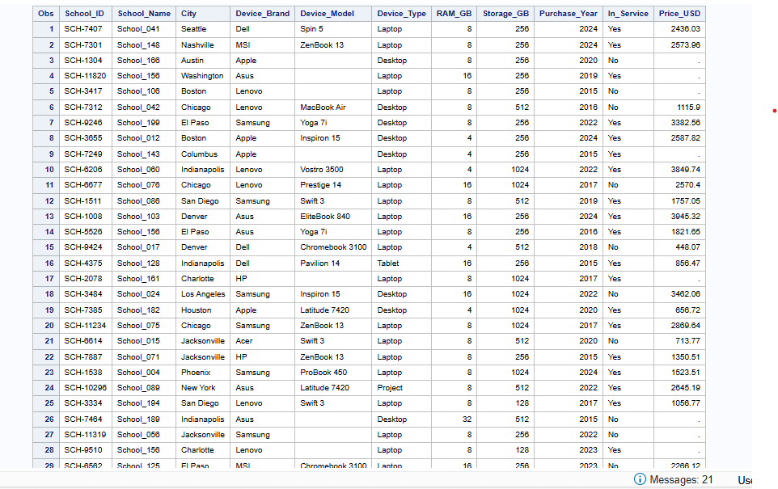
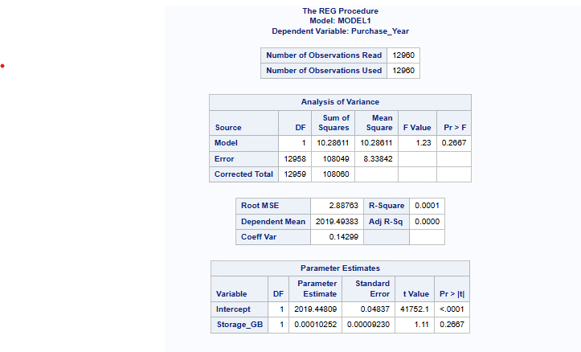
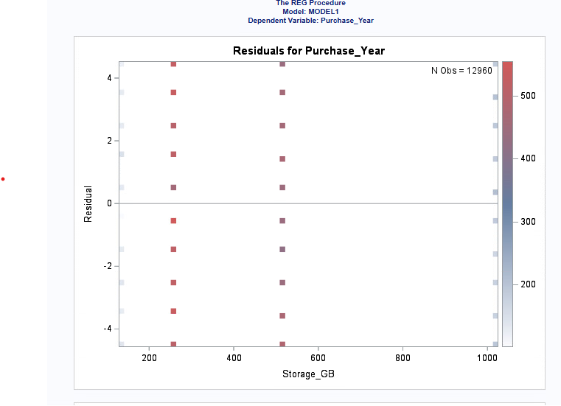

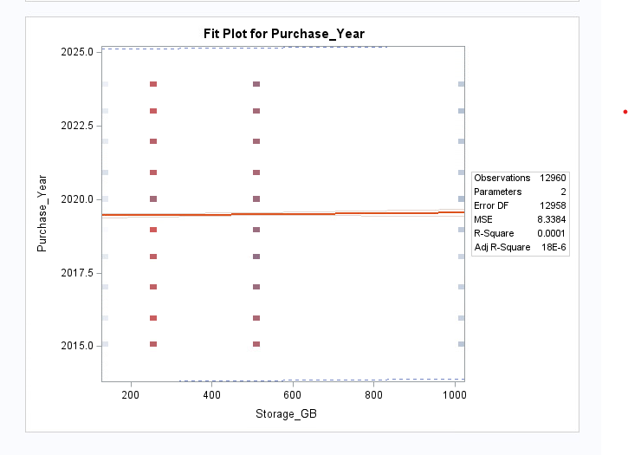
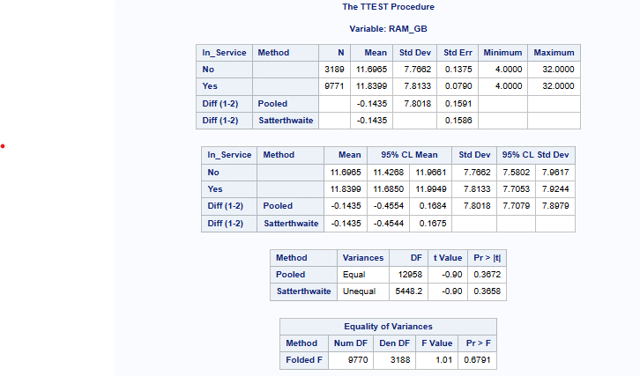

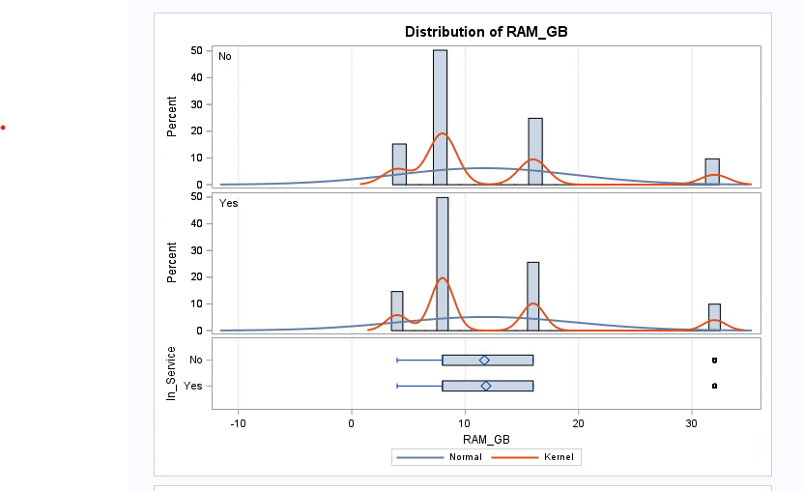
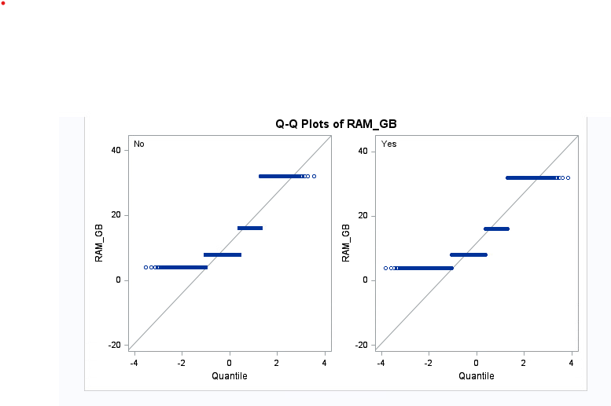
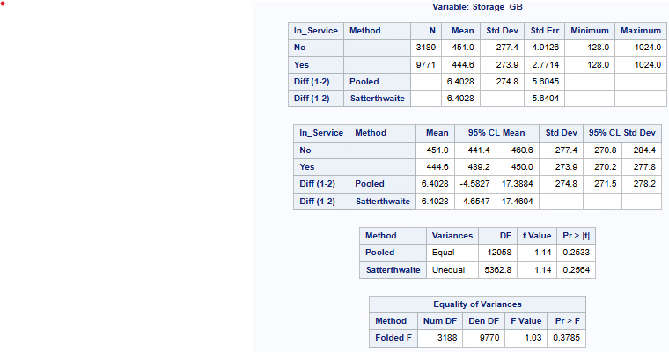
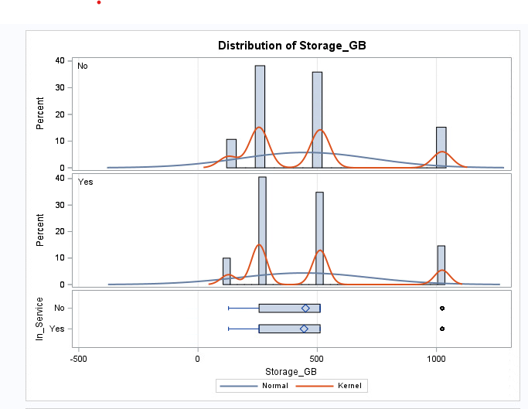
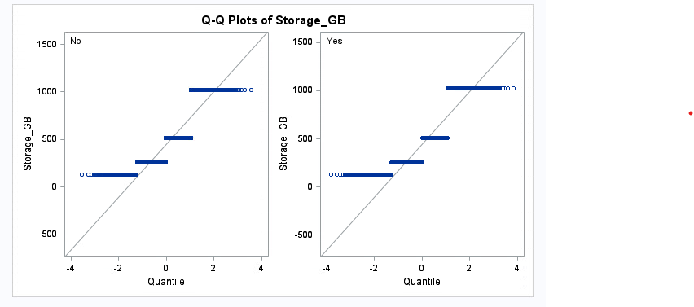
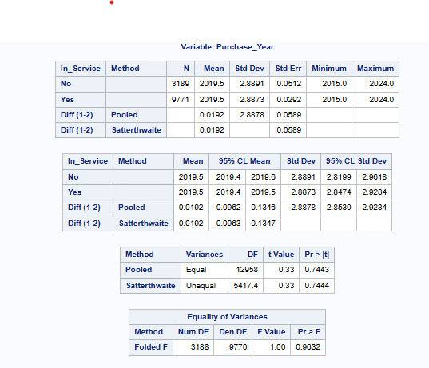

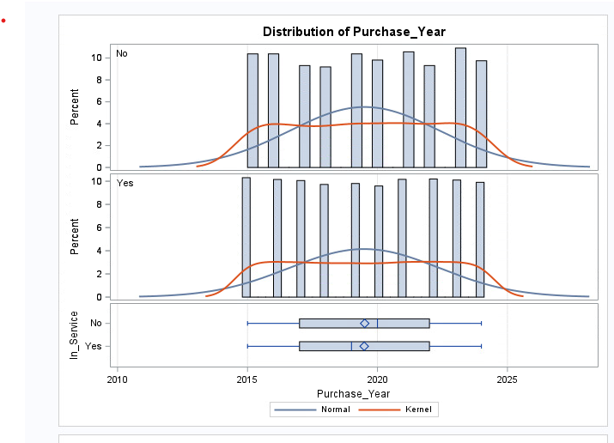
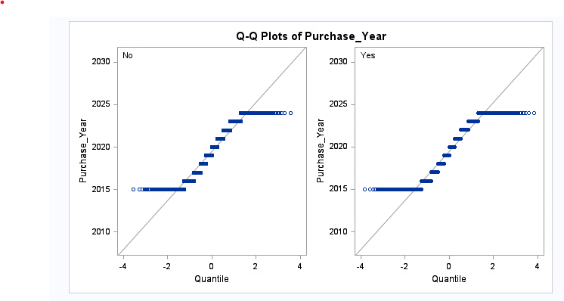
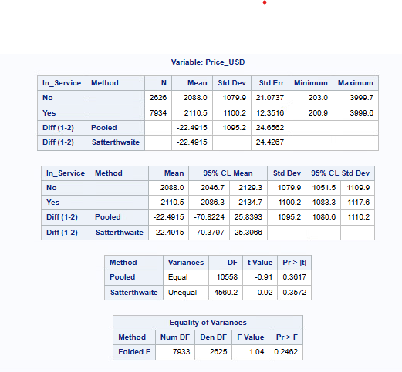
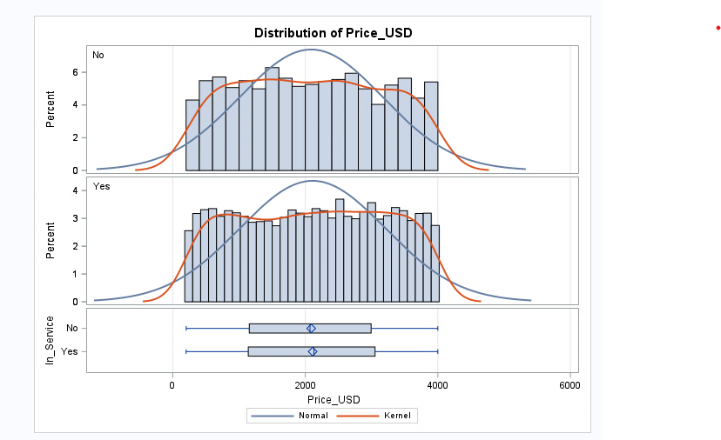
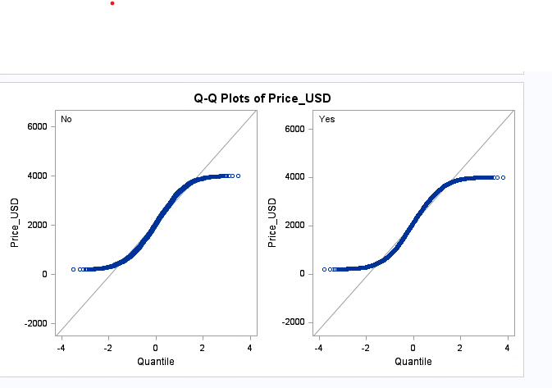
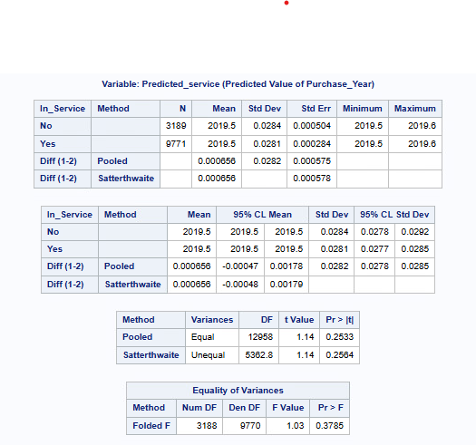
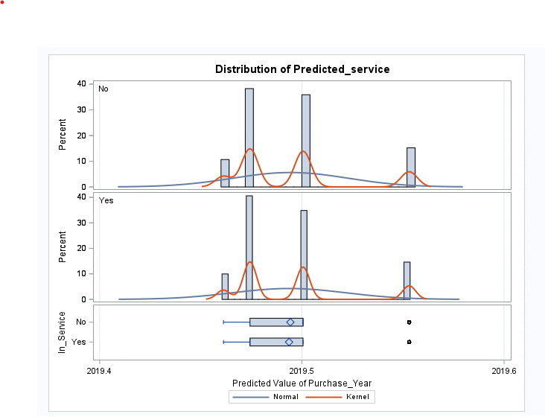
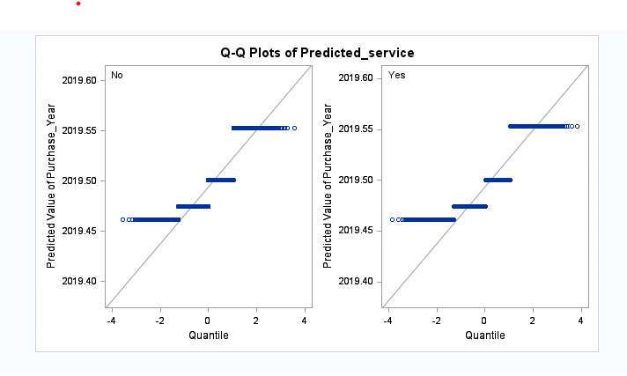
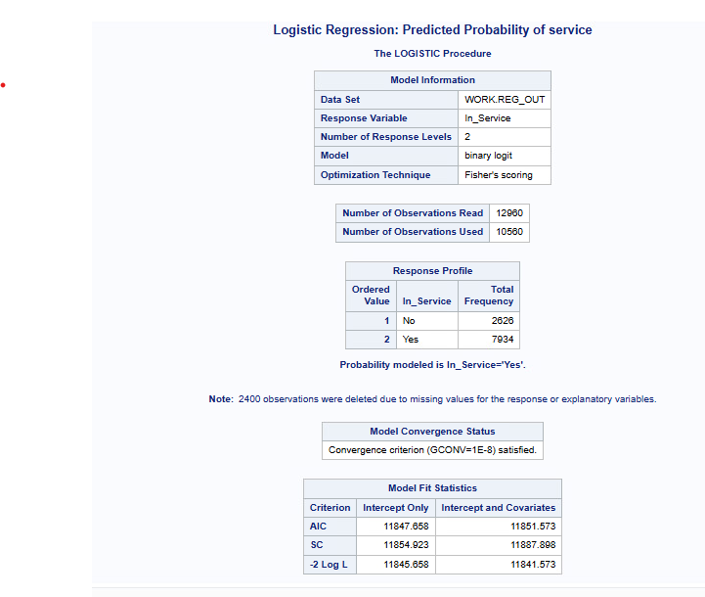
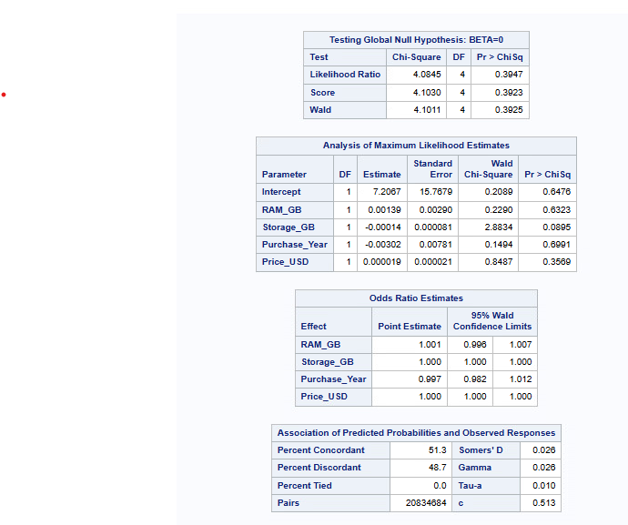

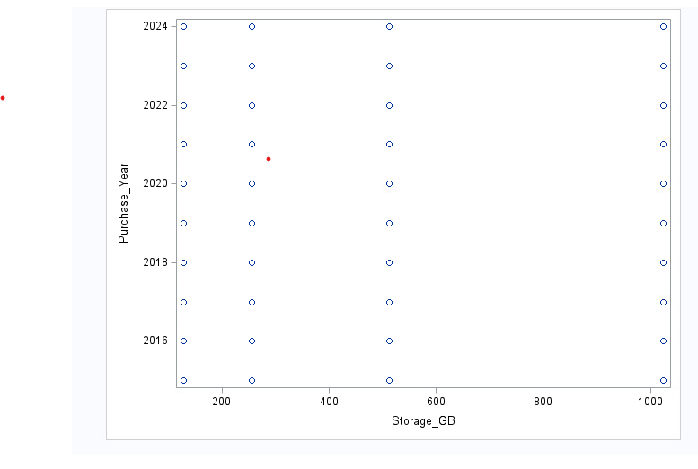

Video link :-
https://dmureplay.cloud.panopto.eu/Panopto/Pages/Viewer.aspx?id=f074c864-ef25-4c34-9b65-b39400bf7cde

